**Wetland Hydroperiod – Final Report**

This study focuses on the hydrology of the eleven (11) selected wetlands located around the coasts of Puerto Rico. Of these wetlands, six have been identified as impaired, while the remaining five were classified as reference or non-impacted, as agreed upon by the team of the Environmental Quality Board of Puerto Rico (PREQB) and the Agricultural Experimental Station of the University of Puerto Rico (AES-UPR). The analysis is based on data collected on the surface hydrology of all eleven wetland sites to document the hydroperiod or soil saturation and/or inundation over the site throughout the monitoring period. The objective of this study is to document whether the site meets the hydrology criteria for wetlands according with USACE (1987) wetland delineation manual. An area meets the wetland hydrology criteria if the upper soil profile remains saturated or inundated continuously for at least five percent (5%) of the growing season[1], or for that matter, 18 consecutive days for Puerto Rico. These areas are classified as wetlands if they also meet the hydrophytic vegetation and hydric soil requirements as indicated in the 1987 USACE delineation manual.

The hydroperiod of each wetland site was monitored for over a year period from early 2021 to the end 2022 using observations wells installed on all the wetland sites. One observation well was installed at or near the indicated centroid of the site and a second well at the topographic transition to upland areas following topographic indicators. Each observation well was instrumented with pressure water sensors (such as the Onset HOBO 14-ft water level logger) for over a whole water year in most sites. The observation well consisted of a 2” diameter slotted schedule 40 PVC pipe buried at least 20” underground and projecting 30” above ground surface for a total of at least 50” total pipe length as shown in Figure 1 (USACE, 2005).

The hydrology criterion established in the 1987 Corps manual states that for a wetland to meet this criterion, the water table must be within 18 inches below the ground surface or the site be inundated for at least five percent of the growing season. This criterion serves as a reference to determine the health and proper functioning of the wetlands, ensuring that their natural hydrological processes remain in balance and can continue to perform their ecological functions. Daily precipitation during the study period at each site was obtained from the National Aeronautical and Space Administration (NASA) Langley Research Center (LaRC) Prediction of Worldwide Energy Resource (POWER) Project’s Hourly 2.1 version 1.0 on 2021/11/23 from NASA (2023).

In the case of the reference wetland sites, all of them met the hydrology criterion. Saturation above the ground surface has been observed, suggesting a healthy and favorable hydrological state in these aquatic ecosystems. However, in the specific case of the wetland located in Loíza, a dry period was recorded in May and June 2022 where the water level remained below ground but within 18” below the ground surface for 54 consecutive days, as shown in Figure 2. Despite this, it was confirmed that the water level never dropped below the 18 inches established by the USACE and EPA criterion, indicating that this wetland also meets the hydrological criterion.

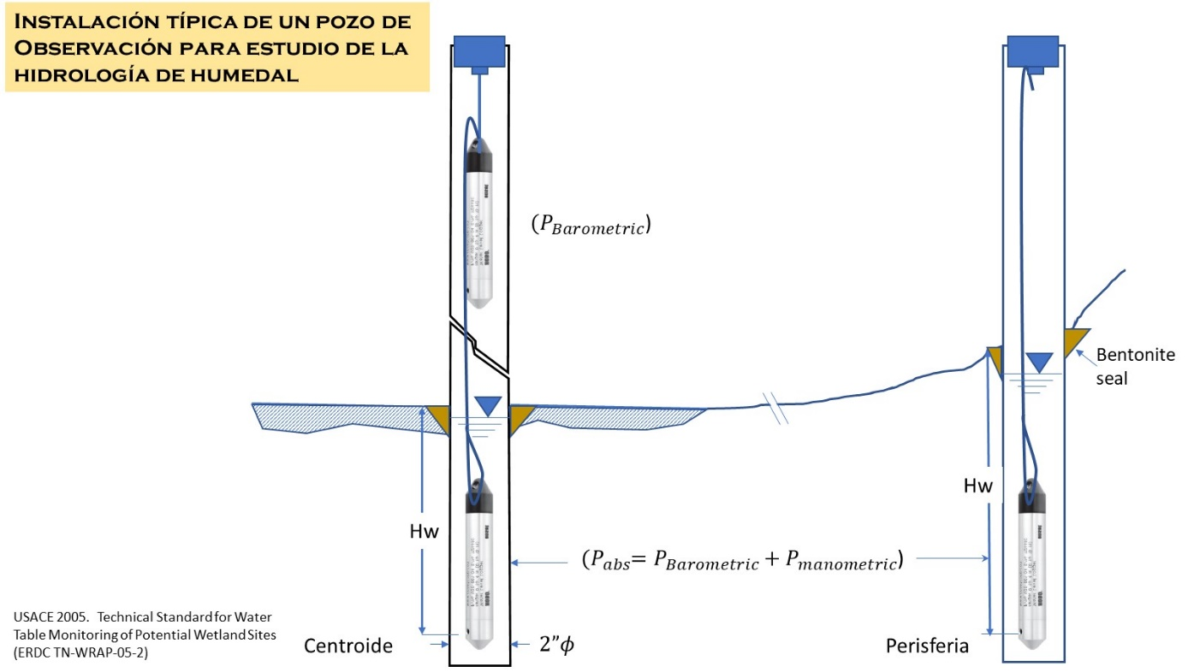

Figure 1. Observation wells at centroid and periphery locations for each wetland site for monitoring wetland hydrology and hydroperiod, (USACE, 2005).

Figure 2. Finca Virginia site wetland hydrology analysis. Precipitation data were collected from PALMA SOLA, PR US (RQC00666725).

The remaining figures for the remaining wetland sites are shown in the appendix of this chapter.

Regarding the impacted wetlands, all of them managed to meet the criterion established in the Corps manual. However, greater variation in the water column was observed in the impacted wetlands as compared to the reference wetland sites. Specifically, in the wetlands located in Canovanas and Luquillo PR3 (impacted wetlands), the water column level remained below the ground surface most of the time but always stayed within 18 inches of ground surface, demonstrating that, despite the alterations, these wetlands continue to maintain their hydrological function according to the established parameters.

**Hydraulic Retention Time (HRT)**

Hydraulic retention time (HRT) is a term describing the time water remains in the wetland area (volume), or the amount of time the water volume is replace by the incoming flow. Hydraulically, HRT is determined by the ratio of the wetland volume above ground (V) and the incoming flow rate (Q) of the water source that reach the wetland area, this is expressed as $HRT= \frac{V}{Q}$. It is equivalent to measuring the time it takes to renew the volume of water over the wetland volume (area).

Table 1 shows the values of hydraulic retention time corresponding to each wetland.

The hydraulic retention time (HRT) in a wetland was calculated using the following formula:

HRT = $\frac{V}{Q}$

Where: HRT = Hydraulic Retention Time (days)

V = Volume of the wetland (m3)

Q = Inflow or water flow entering the wetland (m3/day)

For the calculation of the volume (V = area * depth), the area established by the National Wetland Inventory - U.S. Fish & Wildlife Services and the average observed depth at each reference location were used as references.

Daily flow at each site was determined using daily readings of the water column position and the site’s estimated surface area. The advantage of this flow determination method is that regardless of incoming flow whether subsurface or surface flow is accounted for by the movement of the wetland surface flow elevation, and that measurement was recorded with the sensor at each observation well.

Table 1. Hydrologic Retention Time (HRT) for each wetland

|  |  |  |  |  |  |  |
| --- | --- | --- | --- | --- | --- | --- |
| Wetland Name | Wetland Classification | Area (ha) | Average depth (m) | Volume (m3) | Flow (m3/day) | HRT (days) |
| Vega Baja | Reference | 159.58 | 0.242 | 386,183.6 | 5,022.22 | 77 |
| Manatí | Reference | 70.07 | 0.655 | 458,958.5 | 3,963.75 | 116 |
| Loíza | Reference | 198.45 | 0.060 | 119,070.0 | 9,688.43 | 12 |
| Humacao | Reference | 50.78 | 0.765 | 388,467.0 | 2,975.06 | 131 |
| Arroyo | Reference | 116.20 | 0.647 | 751,814.0 | 3,212.76 | 234 |
| Tortuguero | Impared | 20.90 | 0.439 | 91,751.0 | 471.15 | 195 |
| Rio Grande | Impared | 246.43 | 0.252 | 620,594.2 | 10,769.45 | 58 |
| Pasto Viejo | Impared | 406.18 | 0.685 | 2,782,396.6 | 43,519.12 | 64 |
| Canovanas | Impared | 236.05 | 0.525 | 1,239,262.5 | 16,254.11 | 76 |
| Luquillo PR-3 | Impared | 54.58 | 0.203 | 110,797.4 | 849.85 | 130 |
| Cartagena | Impared | 146.41 | 0.615 | 900,055.8 | 26,243.99 | 34 |

In the case of impacted wetlands, the hydraulic retention time can be affected by the alteration of natural water flow patterns due to nearby human activities or changes in land use. This can result in a shorter retention time and, consequently, a decrease in the wetlands capacity to retain pollutants and purify the water flowing through them.

On the other hand, in non-impacted wetlands, an appropriate hydraulic retention time ensures that natural filtration and purification processes have enough time to take place, contributing to the preservation of high water quality in these ecosystems. Additionally, studying the retention time can help identify seasonal patterns or climatic events that may affect the hydrological behavior of wetlands, thus enabling a better understanding of their resilience and adaptability.

In conclusion, six impacted wetlands and five non-impacted wetlands were identified, evaluating their compliance with the hydrological criterion established by the EPA, which requires a water column of at least 18 inches above the ground surface. The reference wetlands demonstrated compliance with the criterion and saturation above the ground surface, indicating a healthy hydrological state. Although a wetland in Loíza experienced a dry period, it consistently met the standards. The impacted wetlands also met the hydrology criterion, but with greater variation in the water column. Human intervention alters the flow, level, and water quality in impacted wetlands, potentially affecting biodiversity and ecosystem health. Understanding the hydraulic retention time (HRT) is essential, and through its calculation (HRT = V / Q), the wetlands' effectiveness in water filtration and purification was assessed. The affected HRT in impacted wetlands highlights the need to mitigate the effects of human intervention and restore these ecosystems to maintain their hydrological function and ecological role. Overall, this study emphasizes the importance of hydrology in the conservation and proper management of wetlands to safeguard water quality and biodiversity.

References

Ghosh, D., & Gopal, B. 2010. Effect of hydraulic retention time on the treatment of secondary effluent in a subsurface flow constructed wetland. *Ecological Engineering*, *36*(8), 1044–1051. <https://doi.org/10.1016/j.ecoleng.2010.04.017>

National Aeronautical and Space Administration (NASA). Prediction of Worldwide Energy Resource (POWER). http://power.larc.nasa.gov

Rogers, Justin S., Potter, Kenneth, W. Hoffman, Adam R Hoopes, John A. Wu, Chin H; Armstrong, David E. 2009. Journal of the American Water Resources Association; Jun 2009; 45, 3; ProQuest One Academic pg. 628

Tang, Y., Leon, A.S. & Kavvas, M.L. 2020. Impact of Size and Location of Wetlands on Watershed-Scale Flood Control. *Water Resour Manage* **34**, 1693–1707 (2020). <https://doi.org/10.1007/s11269-020-02518-3>

Tomscha, S. A., Bentley, S., Platzer, E., Jackson, B., de Roiste, M., Hartley, S., Norton, K., & Deslippe, J. R. 2021. Multiple methods confirm wetland restoration improves ecosystem services. *Ecosystems and People (Abingdon, England)*, *17*(1), 25–40. <https://doi.org/10.1080/26395916.2020.1863266>

U.S. EPA. 2002. Methods for Evaluating Wetland Condition: Study Design for Monitoring Wetlands. Office of Water, U.S. Environmental Protection Agency, Washington, DC. EPA-822-R-02-015.

U.S. EPA. 2008. Methods for Evaluating Wetland Condition: Wetland Hydrology. Office of Water, U.S. Environmental Protection Agency, Washington, DC. EPA-822-R-08-024.

Vaissière, A.-C.; Quétier, F.; Bierry, A.; Vannier, C.; Baptist, F.; Lavorel, S. 2021. Modeling Alternative Approaches to the Biodiversity Offsetting of Urban Expansion in the Grenoble Area (France): What Is the Role of Spatial Scales in ‘No Net Loss’ of Wetland Area and Function? Sustainability 2021, 13, 5951. <https://doi.org/10.3390/su13115951>

Appendix: Hydroperiod for wetland sites

1. Growing season is defined as the portion of the year when the soil temperature is above biological zero (5oC); therefore, the growing season in Puerto Rico extend to the full year or 365 days.